Code Smell

Refactoring: Refactoring is a systematic process of improving code without creating new functionality that can transform a mess into clean code and simple design.

Clean code : is easy to understand and maintain, and also helps to increase the resulting quality

Refactoring Process: Performing refactoring step-by-step and running tests after each change are key elements of refactoring that make it predictable and safe.

Code smells : problems that can be addressed during refactoring , code smell are easy to spot and fix , but the.y may be just symptoms of a deeper problem with code

Examples : Poor variable naming , bloated classes and methods , magic number , duplications that make the. Code sloppy

- Clean code contains a minimal number of classes and other moving parts
- Clean code passes all tests
- Clean code is easier and cheaper to maintain

Technical debt : (the metaphor of technicall debt in regards to unclean code)

Causes:
- Busniness Pressure
- Lack of understanding the consequence of technical debt
- Lack of tests
- Lack of doc
- Delayed refactoring
- Incompetence

When to refactor:
Rule of Three:
- When u r doing for first time , just get it done
- When your doing something for the second time
- When your doing something for the third time

Checklist of refActor Done right way:
- The code should become cleaner
2. New func should not be created during refactoring
3. All. Existing tests must pass after refactoring

Code smells :

Bloaters :

Long Method | Method contains too many lines of code
Large Class | Class contains many fields/methods/lines of code
Primitive Obsession | Use of primitive instead of small objects ||. Use of constants for coding or for field names
Long Parameter List | More than three or four parameter for a method
Data Clumps | Sometimes different parts of the code contain identical groups of variables (such as parameters for connecting to a database). These clumps should be turned into their own classes.

Object-orientation Abusers:

Switch Statements
You have a complex switch operator or sequence of if statements.

Temporary Field
Temporary fields get their values (and thus are needed by objects) only under certain circumstances. Outside of these circumstances, they’re empty.

Refused Bequest
If a subclass uses only some of the methods and properties inherited from its parents, the hierarchy is off-kilter. The unneeded methods may simply go unused or be redefined and give off exceptions.

Alternative Classes with Different Interfaces
Two classes perform identical functions but have different method names.The programmer who created one of the classes probably didn’t know that a functionally equivalent class already existed.

Change Preventers

These smells mean that if you need to change something in one place in your code, you have to make many changes in other places too. Program development becomes much more complicated and expensive as a result.
Divergent Change
You find yourself having to change many unrelated methods when you make changes to a class. For example, when adding a new product type you have to change the methods for finding, displaying, and ordering products.
Shotgun Surgery
Making any modifications requires that you make many small changes to many different classes.
Parallel Inheritance Hierarchies
Whenever you create a subclass for a class, you find yourself needing to create a subclass for another class.

Dispensables :

Comments,Duplication Code , Lazy Class(class doesn’t do enough to earn your attention, it should be deleted) , data Class , dead Code, Speculative Generality(There’s an unused class , method ,field or parameter)

Message Chains
In code you see a series of calls resembling $a->b()->c()->d()

Refactoring Techniques :
Composing Methods
Much of refactoring is devoted to correctly composing methods. In most cases, excessively long methods are the root of all evil. The vagaries of code inside these methods conceal the execution logic and make the method extremely hard to understand—and even harder to change.
The refactoring techniques in this group streamline methods, remove code duplication, and pave the way for future improvements.
- Extract Method
- Inline Method
- Extract Variable
- Inline Temp
- Replace Temp with Query
- Split Temporary Variable
- Remove Assignments to Parameters
- Replace Method with Method Object
- Substitute Algorithm
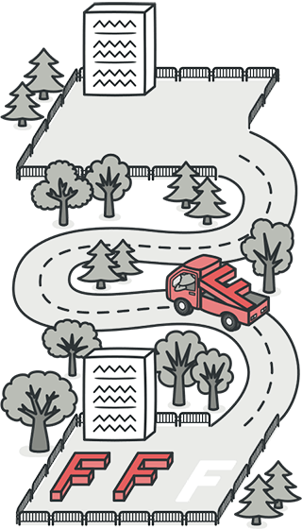
Moving Features between Objects
Even if you have distributed functionality among different classes in a less-than-perfect way, there is still hope.
These refactoring techniques show how to safely move functionality between classes, create new classes, and hide implementation details from public access.
- Move Method
- Move Field
- Extract Class
- Inline Class
- Hide Delegate
- Remove Middle Man
- Introduce Foreign Method
- Introduce Local Extension
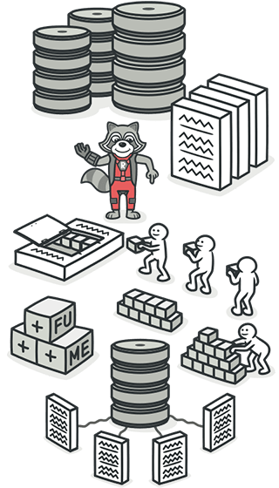
Organizing Data
These refactoring techniques help with data handling, replacing primitives with rich class functionality. Another important result is untangling of class associations, which makes classes more portable and reusable.
- Change Value to Reference
- Change Reference to Value
- Duplicate Observed Data
- Self Encapsulate Field
- Replace Data Value with Object
- Replace Array with Object
- Change Unidirectional Association to Bidirectional
- Change Bidirectional Association to Unidirectional
- Encapsulate Field
- Encapsulate Collection
- Replace Magic Number with Symbolic Constant
- Replace Type Code with Class
- Replace Type Code with Subclasses
- Replace Type Code with State/Strategy
- Replace Subclass with Fields
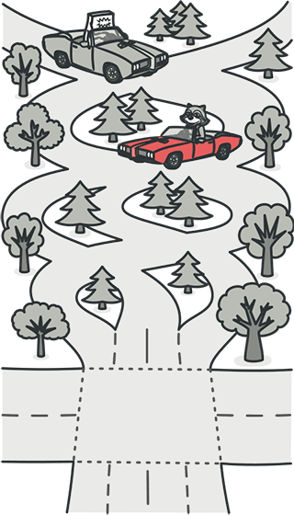
Simplifying Conditional Expressions
Conditionals tend to get more and more complicated in their logic over time, and there are yet more techniques to combat this as well.
- Consolidate Conditional Expression
- Consolidate Duplicate Conditional Fragments
- Decompose Conditional
- Replace Conditional with Polymorphism
- Remove Control Flag
- Replace Nested Conditional with Guard Clauses
- Introduce Null Object
- Introduce Assertion
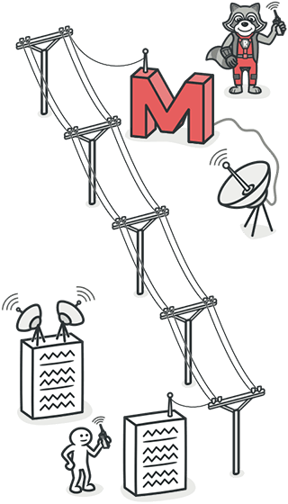
Simplifying Method Calls
These techniques make method calls simpler and easier to understand. This, in turn, simplifies the interfaces for interaction between classes.
- Add Parameter
- Remove Parameter
- Rename Method
- Separate Query from Modifier
- Parameterize Method
- Introduce Parameter Object
- Preserve Whole Object
- Remove Setting Method
- Replace Parameter with Explicit Methods
- Replace Parameter with Method Call
- Hide Method
- Replace Constructor with Factory Method
- Replace Error Code with Exception
- Replace Exception with Test
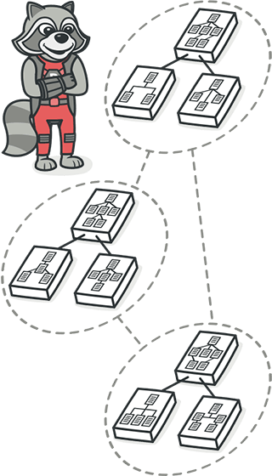
Dealing with Generalization
Abstraction has its own group of refactoring techniques, primarily associated with moving functionality along the class inheritance hierarchy, creating new classes and interfaces, and replacing inheritance with delegation and vice versa.
- Pull Up Field
- Pull Up Method
- Pull Up Constructor Body
- Push Down Field
- Push Down Method

